# Inspection review

## What is Inspection review

**# Source**: **Chatgpt (GPT-5-Standard) at [8/14/2025]**

**Inspection review** is the **most formal** type of static review in software testing — think of it as a **structured, rules-driven “code/test/documents audit”** where the main goal is to **find defects, not discuss solutions** during the meeting.

## **Key Points About Inspection**

**# Source**: **Chatgpt (GPT-5-Standard) at [8/14/2025]**

* **Objective:** Detect defects **early** in software artifacts (requirements, test cases, code, design docs, etc.)
* **Formality:** Highly structured with **defined roles**, a checklist, pre-meeting preparation, and documented findings.
* **Origin:** Based on Michael Fagan’s inspection process (IBM, 1970s).
* **Output:** Formal **defect log** and metrics (number of defects found, severity, time spent, etc.).

## **Roles in Inspection**

**# Source**: **Chatgpt (GPT-5-Standard) at [8/14/2025]**

1. **Moderator** – Plans the inspection, runs the meeting, keeps it on track.
2. **Author** – Creator of the document under review (e.g., tester who wrote test cases).
3. **Reviewers/Inspectors** – Experts who check the work for defects.
4. **Recorder/Scribe** – Notes every defect found.
5. **Manager (optional)** – Monitors quality trends.

## **Typical Inspection Steps in Testing**

**# Source**: **Chatgpt (GPT-5-Standard) at [8/14/2025]**

1. **Planning** – Moderator schedules review, selects reviewers, sends materials.
2. **Overview (optional)** – Author explains context to reviewers.
3. **Preparation** – Reviewers study the document alone, using checklists.
4. **Inspection Meeting** –  
   * Moderator leads discussion.
   * Reviewers call out **defects** (ambiguities, missing coverage, incorrect expected results, etc.).
   * No fixing or problem-solving in the meeting — just **logging defects**.
5. **Rework** – Author corrects the defects.
6. **Follow-up** – Moderator checks fixes and closes the review.

## **Real-World Example in Testing**

**# Source**: **Chatgpt (GPT-5-Standard) at [8/14/2025]**

**Artifact:** Test cases for an online shopping cart  
 **Checklist Items:**

* Is every functional requirement covered?
* Are boundary values tested?
* Is expected result specific and measurable?
* Are preconditions clearly stated?

**During Inspection Meeting:**

* Reviewer:  
    
    
   “In Test Case #12, expected result says ‘order placed successfully’ — missing exact confirmation message as per REQ-05.”
* Reviewer:  
    
    
   “No test case for cart quantity = 0, which is a boundary value.”
* Scribe logs these as **defects** in JIRA with tags “Test Case Review Defect.”

## **Difference from Walkthrough & Technical Review**

**# Source**: **Chatgpt (GPT-5-Standard) at [8/14/2025]**

* **Walkthrough** → informal knowledge-sharing, no defect metrics.
* **Technical Review** → formal, but may include discussion and fixes during meeting.
* **Inspection** → **most formal**, strict process, **defect logging only**, uses checklists, fixes happen **after** the meeting.

## Technical Review vs Inspection

**# Source**: **Chatgpt (GPT-5-Standard) at [8/14/2025]**

Here’s the **clear, real-world breakdown** of **Technical Review** vs **Inspection** in software testing, so you can actually tell them apart when they happen in practice:

### 1. Purpose

**# Source**: **Chatgpt (GPT-5-Standard) at [8/14/2025]**

* **Technical Review** → Evaluate technical quality and suitability of a work product.  
  + Example: Reviewing **test automation scripts** for correct framework usage, maintainability, and performance.
* **Inspection** → Find **defects only** (not to discuss solutions) in a formal, measurable process.  
  + Example: Reviewing **manual test cases** line-by-line against requirements using a checklist.

### 2. Formality

**# Source**: **Chatgpt (GPT-5-Standard) at [8/14/2025]**

* **Technical Review** → **Formal or semi-formal** — structure exists, but not as strict as inspection.
* **Inspection** → **Most formal** — rigid process with documented roles, checklists, and defect logging.

### 3. Roles

**# Source**: **Chatgpt (GPT-5-Standard) at [8/14/2025]**

* **Technical Review**
  + Author
  + Moderator (optional)
  + Peers/Experts (technical specialists)
* **Inspection**
  + Author
  + Moderator
  + Reviewers/Inspectors
  + Recorder/Scribe
  + (Optional) Manager for oversight

### 4. Discussion Rules

**# Source**: **Chatgpt (GPT-5-Standard) at [8/14/2025]**

* **Technical Review** → You **can** discuss solutions and improvements during the meeting.
* **Inspection** → **No fixing or solution discussion** in the meeting — only identify and log defects.

### 5. Preparation

**# Source**: **Chatgpt (GPT-5-Standard) at [8/14/2025]**

* **Technical Review** → Reviewers prepare in advance, but flexibility is allowed.
* **Inspection** → Mandatory pre-meeting preparation with **checklists**.

### 6. Output

**# Source**: **Chatgpt (GPT-5-Standard) at [8/14/2025]**

* **Technical Review** → Recommendations for improvements, plus possible defect list.
* **Inspection** → Formal **defect log** + metrics (number of defects, severity, time spent, etc.).

### 7. Real Testing Examples

**# Source**: **Chatgpt (GPT-5-Standard) at [8/14/2025]**

**Technical Review Example**

* Artifact: Selenium automation scripts
* Finding: "This script uses hard-coded waits instead of dynamic waits — will slow down execution. Suggest using WebDriverWait."
* Meeting includes brainstorming best implementation.

**Inspection Example**

* Artifact: Test case document for login feature
* Finding: "Test case for invalid password missing expected error code from REQ-03."
* Logged as defect #TC-001 in JIRA.
* No discussion on how to fix — author will correct later.

### **Quick Side-by-Side Table**

**# Source**: **Chatgpt (GPT-5-Standard) at [8/14/2025]**

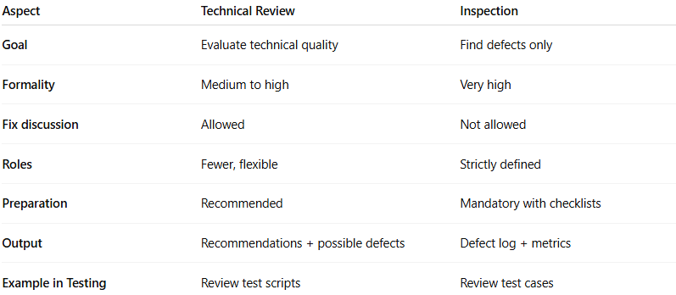

| **Aspect** | **Technical Review** | **Inspection** |
| --- | --- | --- |
| **Goal** | Evaluate technical quality | Find defects only |
| **Formality** | Medium to high | Very high |
| **Fix discussion** | Allowed | Not allowed |
| **Roles** | Fewer, flexible | Strictly defined |
| **Preparation** | Recommended | Mandatory with checklists |
| **Output** | Recommendations + possible defects | Defect log + metrics |
| **Example in Testing** | Review test scripts | Review test cases |